Wolverine Football
Senior Memory Package
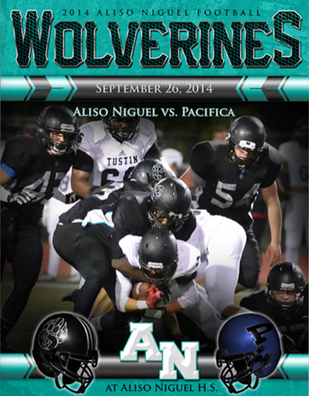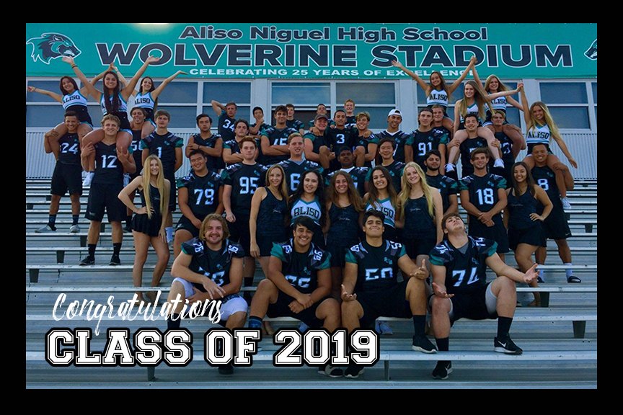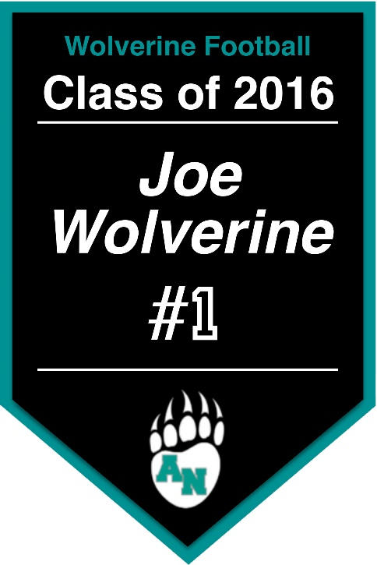

Choose Your Package
Package A - $215 |  | Package B - $165 |  | Package C - $135
(1) Full Page Ad in Game Program |  | (1) Half Page Ad in Game Program |  | (1) Quarter Page Ad in Game Program
(1) 3' x 5' Senior Pennant |  | (1) 3' x 5' Senior Pennant |  | (1) 3' x 5' Senior Pennant
(1) 8" x 10" "Seniors" Group Photo |  | (1) 8" x 10" "Seniors" Group Photo |  | (1) 8" x 10" "Seniors" Group Photo
(1) Senior Night Varsity Game Program |  | (1) Senior Night Varsity Game Program |  | (1) Senior Night Varsity Game Program

Package Inclusion Details
Game Program Ads – Ad appears in every Varsity home game program for the 2019 season.
Field Banner – Banner is hung above the snack bar for the entire 2019 season, and then it becomes a gift to your senior player at the Varsity banquet.
Group Photo – Photo includes all senior football, pep squad, band and accompanying Friday night performance members.
Senior Night Program – A free copy of the Senior Night Varsity home game program will be given to each family before the start of the game.

Package A - Options
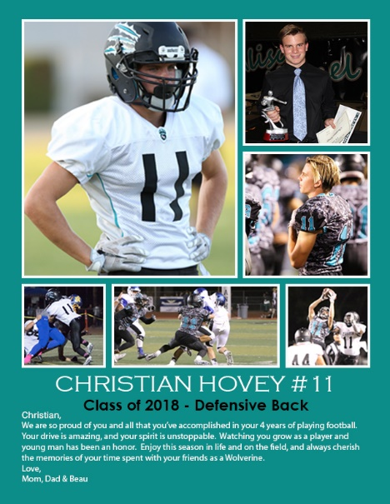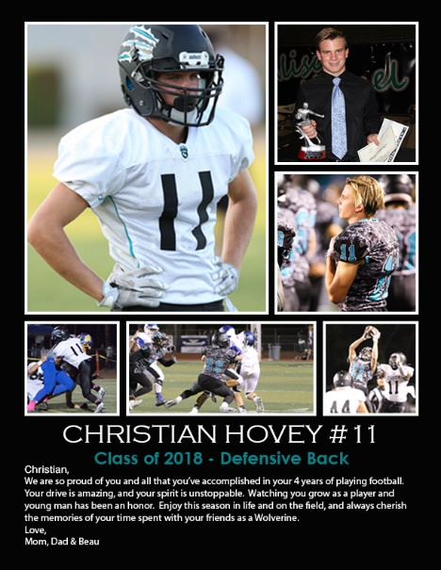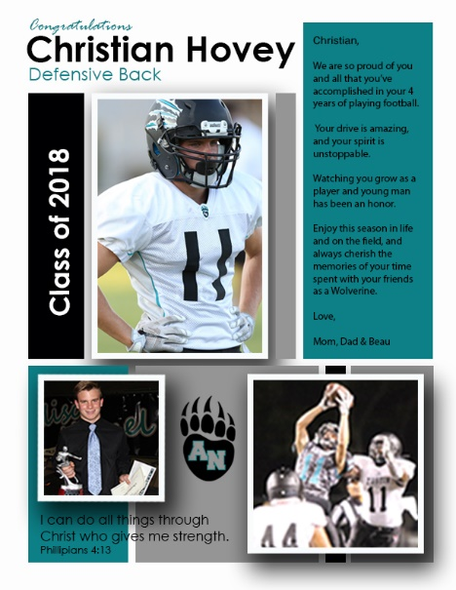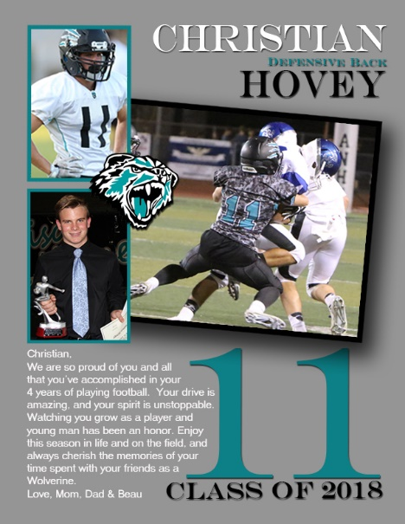
Option #1 Option #2 Option #3 Option #4

Package B - Options
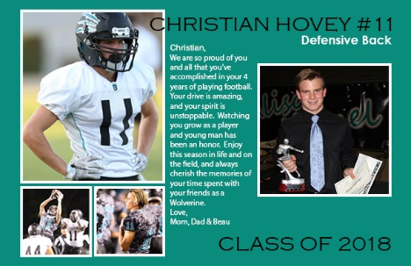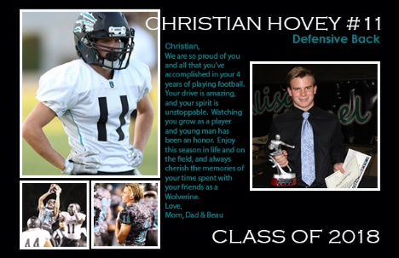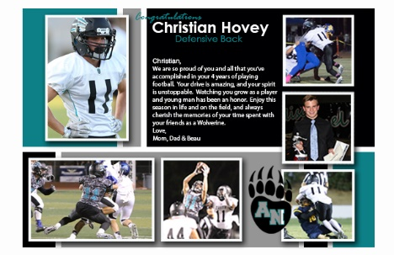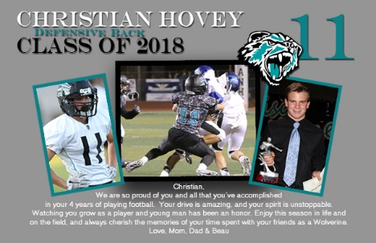
Option #1 Option #2 Option #3 Option #4

Package C - Options
Notes:
Text Copy: Text allotted per layout is limited and will be sized to fit without compromising readability, otherwise text may need to be edited at the designer’s discretion.
Photos: Photos must be provided to the designer in a jpg or pdf format. If you are in need of photos, you may go to alisoniguelfootball.com, click on the photos icon, and download photos from those available.
Camera Ready Ad Option: You may provide your own appropriately sized camera ready ad in a pdf format.
Print Deadlines: Delayed payment and failing to provide text copy or photos in time may result in your ad not appearing in early issues.
Contact: Send all text copy and photos to Patty Hovey – pattytheprincess@cox.net
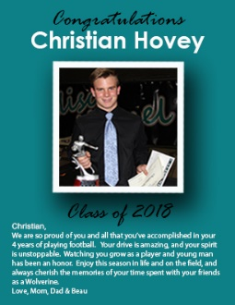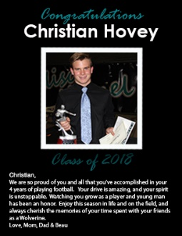
Option #1 Option #2

